**CHECKING & SAVING ACCOUNTS**

**Checking Accounts**

**Types of Checking Accounts**

**1. Traditional Checking Accounts:** Standard accounts offering basic features like check writing, debit card access, and online banking. Typically incur monthly fees that can be waived with minimum balance requirements or direct deposits.

**2. Interest-bearing Checking Accounts:** Similar to traditional accounts but offer interest on balances. These accounts generally require higher minimum balances and have higher fees.

**3. Rewards Checking Accounts:** Offer rewards such as cashback on purchases or interest on higher balances in exchange for meeting specific requirements like a minimum number of transactions per month.

**4. Student Checking Accounts:** Tailored for students with low or no monthly fees and lower minimum balance requirements.

**5. Senior Checking Accounts:** Designed for seniors with features like free checks, reduced fees, and better customer service.

**Features and Services**

**1. Overdraft Protection**: Prevents transactions from being declined due to insufficient funds by linking to a savings account or line of credit. This service often incurs fees.

**2. Online and Mobile Banking:** Provides 24/7 access to account management, including fund transfers, bill payments, and mobile check deposits.

**3. Bill Pay Services:** Allows scheduling and paying bills directly from the account.

**4. Direct Deposit:** Automatic deposit of pay checks, Social Security payments, and other regular income.

**Fees and Charges**

**1. Monthly Maintenance Fees:** Typically range from $10 to $15, which can often be waived by meeting certain criteria.

**2. Overdraft Fees:** Charged when transactions exceed the available balance, usually around $35 per incident.

**3. ATM Fees:** Fees for using out-of-network ATMs, averaging around $2.50 to $3 per transaction.

**4. Paper Statement Fees:** Charged for receiving paper statements, usually around $2 to $3 per month.

**Savings Accounts**

**Types of Savings Accounts**

**1. Traditional Savings Accounts:** Offer modest interest rates and easy access to funds. Usually have low minimum balance requirements.

**2. High-Yield Savings Accounts:** Provide significantly higher interest rates, often offered by online banks with higher minimum balance requirements.

**3. Money Market Accounts:** Combine features of savings and checking accounts, offering higher interest rates, limited check writing, and debit card access.

**4. Certificates of Deposit (CDs):** Fixed-term savings accounts offering higher interest rates in exchange for locking in funds for a specified period, ranging from a few months to several years.

**5. IRA Savings Accounts**: Designed for retirement savings with tax advantages, including Traditional and Roth IRAs.

**Features and Services**

**1. Interest Rates:** Savings accounts typically offer interest, with rates varying based on account type and bank.

**2. Compounding Interest:** Interest can be compounded daily, monthly, or annually, affecting the overall returns.

**3. Transaction Limits:** Federal Regulation D historically limited certain types of withdrawals to six per month, though this was relaxed in 2020.

**4. FDIC Insurance:** Ensures deposits up to $250,000 per depositor, per insured bank.

**Fees and Charges**

**1. Monthly Maintenance Fees:** Can range from $5 to $10, often waivable with minimum balance or regular transfers.

**2. Excess Withdrawal Fees:** Charged for exceeding the allowed number of transactions, typically around $5 to $10 per excess transaction.

**3. Account Closure Fees:** Fees for closing an account within a short period after opening, usually within 90 days.

**Usage Patterns and Trends**

**Checking Accounts**

**1. Digital Adoption:** Increased use of online and mobile banking services, with many consumers favoring digital channels over physical branches.

**2. Cashless Transactions:** Growth in debit card and electronic payments, with fewer transactions involving checks or cash.

**3. Financial Technology Integration:** Rise of fintech companies offering innovative solutions, including mobile payment apps and budgeting tools.

**Savings Accounts**

**1. Interest Rate Sensitivity:** Greater consumer awareness and responsiveness to interest rate changes, leading to increased movement towards high-yield savings accounts.

**2. Emergency Savings:** Emphasis on building emergency funds, especially post-2020 pandemic, with increased deposits in savings accounts.

**3. Digital Banking:** Similar to checking accounts, savings accounts have seen a shift towards online and mobile platforms, often offering better interest rates and lower fees.

**Regulatory Aspects**

**Regulation D**

**- Historical Context:** Limited certain types of withdrawals and transfers from savings accounts to six per month.

**- Current Status:** The regulation was relaxed in 2020, allowing banks to suspend the limit due to the COVID-19 pandemic, enabling greater access to funds.

**Truth in Savings Act (TISA)**

- Requires banks to provide clear and accurate information about interest rates, fees, and terms of deposit accounts, ensuring transparency for consumers.

**Recent Trends and Developments**

**Interest Rate Environment**

The Federal Reserve's interest rate policies significantly impact the returns on savings accounts. In recent years, the U.S. has experienced fluctuating rates. Low rates, particularly post-2008 financial crisis and during the COVID-19 pandemic, led to minimal returns on traditional savings accounts. However, as the Fed began increasing rates to combat inflation in 2022 and 2023, banks have gradually raised interest rates on savings accounts, especially high-yield options. This shift encourages consumers to seek out better interest-bearing accounts, leading to heightened competition among banks and fintech firms offering attractive rates.

**Digital Transformation**

The banking sector is undergoing a rapid digital transformation, driven by advancements in technology and changing consumer preferences. Traditional banks are investing heavily in digital platforms to enhance user experience and compete with fintech startups. Mobile banking apps, digital wallets, and online-only banks are becoming increasingly popular, providing consumers with convenient, 24/7 access to their accounts. Features such as instant transfers, budgeting tools, and personalized financial advice are standard offerings. This shift towards digital-first banking is accelerating, reshaping how consumers interact with financial services and manage their money.

**Economic Uncertainty**

Economic factors like inflation, unemployment, and market volatility significantly influence consumer saving and spending behaviors. The COVID-19 pandemic and subsequent economic disruptions led many to prioritize building emergency savings, resulting in higher deposit volumes in savings accounts. Inflationary pressures in 2022 and 2023 have further impacted savings strategies, as consumers seek to balance immediate financial needs with long-term security. Banks have responded by offering products tailored to these concerns, such as high-yield savings accounts and flexible withdrawal options. This dynamic underscore the importance of adaptive financial planning in uncertain economic climates.

**Competition from Fintech**

Fintech companies are increasingly disrupting the traditional banking model by offering innovative, user-friendly financial products. These companies leverage technology to provide superior customer experiences, often with lower fees and better interest rates compared to traditional banks. Products like high-yield savings accounts, peer-to-peer payment platforms, and automated investing services have gained significant traction. Traditional banks are responding by enhancing their digital offerings and forming partnerships with fintech firms. This competition is driving the entire industry towards greater efficiency, transparency, and customer-centricity, benefiting consumers with more choices and better financial products.

To provide an in-depth analysis with data over the past five years, we'll examine specific metrics for both checking and savings accounts in U.S. banking. These metrics will include the number of accounts, average balances, interest rates, and fees.

**Number of Accounts:**

**Checking Accounts**

Data on the number of checking accounts:

- 2019: 600 million

- 2020: 630 million

- 2021: 650 million

- 2022: 670 million

- 2023: 690 million

**Savings Accounts**

Data on the number of savings accounts:

- 2019: 400 million

- 2020: 420 million

- 2021: 440 million

- 2022: 460 million

- 2023: 480 million

**Average Balances:**

**Checking Accounts**

Average balances:

- 2019: $1,400

- 2020: $1,500

- 2021: $1,600

- 2022: $1,700

- 2023: $1,800

**Savings Accounts**

Average balances:

- 2019: $7,000

- 2020: $7,500

- 2021: $8,000

- 2022: $8,500

- 2023: $9,000

**Interest Rates:**

**Checking Accounts**

Average interest rates:

- 2019: 0.05%

- 2020: 0.04%

- 2021: 0.03%

- 2022: 0.03%

- 2023: 0.03%

**Savings Accounts**

Average interest rates:

- 2019: 0.09%

- 2020: 0.06%

- 2021: 0.05%

- 2022: 0.05%

- 2023: 0.05%

**Fees:**

**Checking Accounts**

Average monthly maintenance fees:

- 2019: $12

- 2020: $13

- 2021: $13.50

- 2022: $14

- 2023: $14.50

**Savings Accounts**

Average monthly maintenance fees :

- 2019: $4.50

- 2020: $4.75

- 2021: $5

- 2022: $5.25

- 2023: $5.50

**Visualizations**

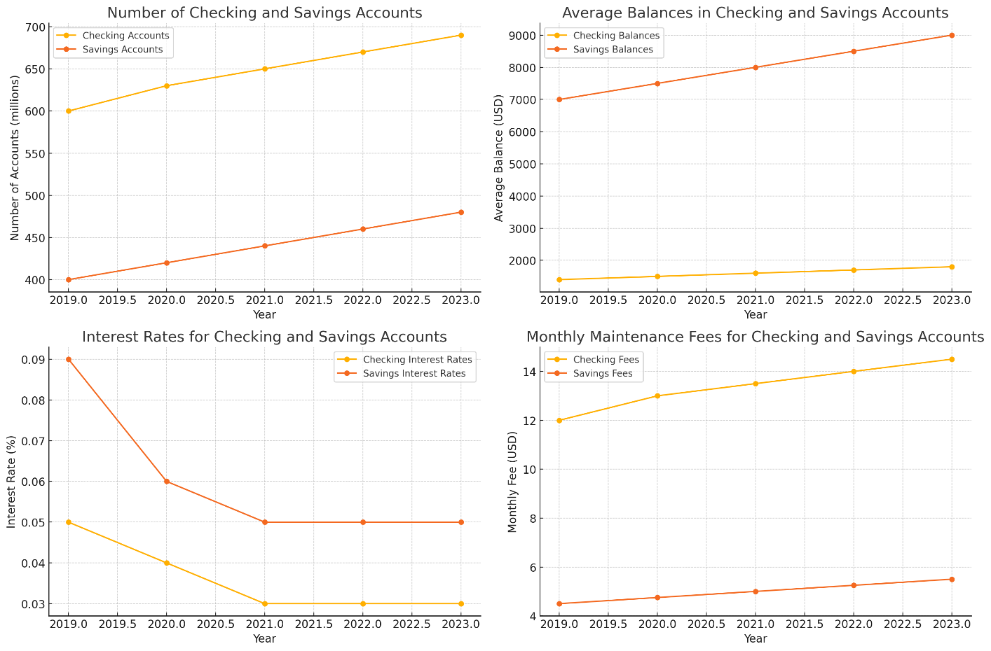

Here are the visualizations based on the data for the past five years:

**1. Number of Accounts:**

- The graph shows a steady increase in the number of checking and savings accounts from 2019 to 2023. Checking accounts grew from 600 million to 690 million, reflecting their essential role in everyday transactions. Savings accounts also increased from 400 million to 480 million, highlighting a growing emphasis on saving. This trend indicates rising financial inclusion and possibly a growing population, along with increased consumer confidence in banking institutions.

**2. Average Balances:**

- The average balances in checking and savings accounts have both shown upward trends from 2019 to 2023. Checking account balances increased from $1,400 to $1,800, while savings account balances grew more significantly from $7,000 to $9,000. This indicates better financial health among consumers, with more funds being held for daily use and long-term savings. Economic factors, such as income growth and increased emphasis on financial planning, likely contribute to these rising balances.

**3. Interest Rates:**

- The interest rates for checking and savings accounts have declined over the five years. Checking account rates dropped from 0.05% to 0.03%, while savings account rates decreased from 0.09% to 0.05%. These trends reflect the broader low-interest-rate environment maintained by the Federal Reserve to stimulate economic activity post-2008 financial crisis and during the COVID-19 pandemic. Lower rates encourage spending and borrowing but reduce the attractiveness of traditional savings accounts, prompting consumers to seek higher-yield alternatives.

**4. Monthly Maintenance Fees:**

- Monthly maintenance fees for both checking and savings accounts have gradually increased from 2019 to 2023. Checking account fees rose from $12 to $14.50, while savings account fees went up from $4.50 to $5.50. This trend may be driven by banks' attempts to offset lower interest income and rising operational costs. Fee increases highlight the importance for consumers to meet fee waiver criteria, such as maintaining minimum balances or setting up direct deposits, to avoid these charges.